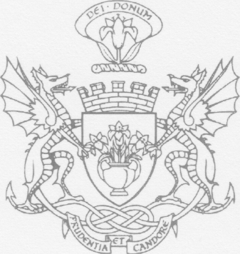
THE LORD PROVOST
CITY OF DUNDEE
Lord Provost John R Letford JP
requests the pleasure of the company of
Mr & Mrs Innes Duffus
at a
Civic Reception
to be held in the
City Chambers
on
Thursday, 31 August 2006
at
7:00pm
on the occasion of
Celebration of 450th Anniversary of The Fraternity of Masters & Seamen in Dundee
City Chambers Dundee DD1 38T
o:

