Clerks Medal
This shows the shield of Arms, crest and Motto recorded in 1881 in name of Robert Crawfurd Walker, Solicitor in Dundee. He was the eldest son of Crawfurd Walker, Merchant in Dundee and Isabella, daughter of George Thoms, Merchant in Dundee and one of the Magistrates of that Burgh. Crawfurd Walker was son of the Reverend Robert Walker, Minister of the Gospel at Cupar, Fife, and Jane Young. Robert Walker was the son of William Walker residing in Carnwarth, Lanark and his wife Helen Crawford.
It was found by Mrs Pamela Ormond, daughter of late Clerk John Boath whilst going through her fathers safe after the death of his wife.
Shield: Or, a saltire Sable, on a Chief Ermine a Cross moline of the Second between two Pallets Gules.
Crest: a Stag hound's Head Proper collared Or
Motto: SAPERE AUDE

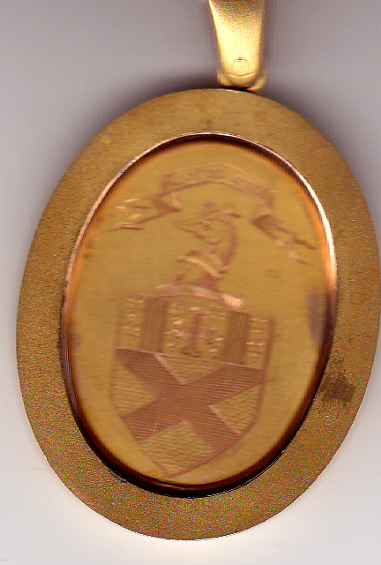

His grandfather was George Thoms. He was on the leet for Dean of Guild in 1815 and Kirkmaster in 1819. His son was PH Thoms, very prominent in Dundee in mid C19. P H Thoms was Agent of The National Bank of Scotland. I think that would not have been a full time job as many Bank Agents then were prominent business men selected by the Banks to obtain customers. There is a memorial stained glass window in St Mary's Church for the Thoms family which has some family information inscribed on it.

The Carnwath connection sounds right - there are Crawford placenames and surnames in the Upper Ward of Lanarkshire. I have not heard of the Rev Robert Walker of Cupar- the only Rev. Robert Walker I have heard of was a bit earlier and has been 'immortalised' as an icon of Scotttish Art - Raeburn's 'The Skating Minister' ! The Fasti which you can now look up in the web may have some more info. about the Cupar Rev R.W.

The oldest Law Directory is dated 1883 and Mr Robert C Walker practised on his own account in Dundee at that time. The only change appears in 1907 when his son, Norman C Walker, joined him and the practice became Robert C Walker & Son, 5 Whitehall Street, Dundee

