The Fraternity of Masters and Seamen in Dundee
Archivist’s Discoveries and Stories
January 2015

I continue where I left off my December ’14 contribution by noting that a Captain McLelland of the ‘Narwhal” donated one sealskin to the City on the 27th of April 1874. Later that same year, on the 30th of November, Captain Kilgour of the “Polynia” donated a sledge left by one of the first Franklin Search Expeditions in Batty Bay, Prince Regent Inlet. Both of these ships were whalers and the ‘Friends of the Dundee City Archives’ web pages tells us that by the 1859 whaling season the first custom built steam whaler was in use by the Dundee fleet, this grew to 6 in 1861 then to 12 in 1867. The names of the steam whalers can be extracted from the various records available and to date I have found the; “Polynia”; “Narwhal”: “Artic”; “Erik”; “Esquimaux”; “Victor”; “Camperdown”; “Ravenscraig”; “Jan Mayen”; “Intrepid”; “Aurora”: So I am one short of the 12 in 1867.

Now back to the “Polynia” and the sledge and forgive me if I appear to be telling my grannie how to suck eggs since many of you will be better versed in history than I. What follows is for those like me who need to be reminded. John Franklin, or Sir John Franklin as he was, was not the first choice to lead the expedition to attempt to find the North West Passage. Sir John Barrow became Second Secretary to the Admiralty in 1804 and for the rest of his political career promoted Arctic voyages in an attempt to discover a navigable North West Passage around the North of Canada. Immediately prior to 1845 and now in his 82nd year, Barrow planned another expedition and offered its command, first to William Parry who ‘politely declined’, then to James Clark Ross who also declined giving his reason that he had promised his new wife to give up Arctic exploration, then James Fitzjames but he was rejected by the Admiralty because he was too young. Another two candidates were considered and rejected for different reasons. Finally Sir John was offered the post, which he accepted and he left England in the summer of 1845 with the HMS “Erebus” and HMS “Terror”. It is known that Franklin wintered over 1845/6 at Beechey Island to the North of Batty Bay and Prince Regent inlet where the “Polynia” sledge was found by Captain Kilgour and his crew. It is also known that both the Erebus and Terror became trapped in the ice in September 1846 a little to the North and West of King William Island. It was to be many years later before the true fate of Franklin and his 127 men became known. From 1848 to 1874, the year when Captain Kilgour donated the sledge, more than 14 rescue expeditions were launched in bids to find Franklin, his ships and men. It is now known that Franklin died on the 11th of June 1847.

The sledge was said to have been left by one of the first search expeditions in Batty Bay, Prince Regent Inlet. This being the case its source can be narrowed down to belonging to either the 1850 mission by Charles Forsyth, financed by Lady Franklin that sledged on Somerset Island (Batty Bay is on Somerset Island), or the 1851 one led by William Kennedy who found Bellot Strait proving that Somerset Island was indeed an island. Logic would tend to favour the former since specific mention is made of sledging on the island. The following diagram identifies the area where Franklin visited.
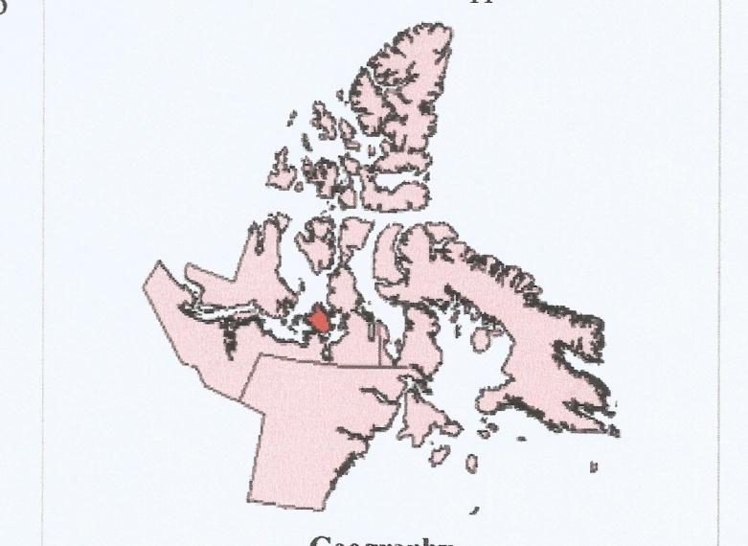
Somerset Island. Batty Bay. Prince Regent Inlet.
Sledge found here.
Beechey Island
Baffin Island
King William Island where Franklin and his men perished.

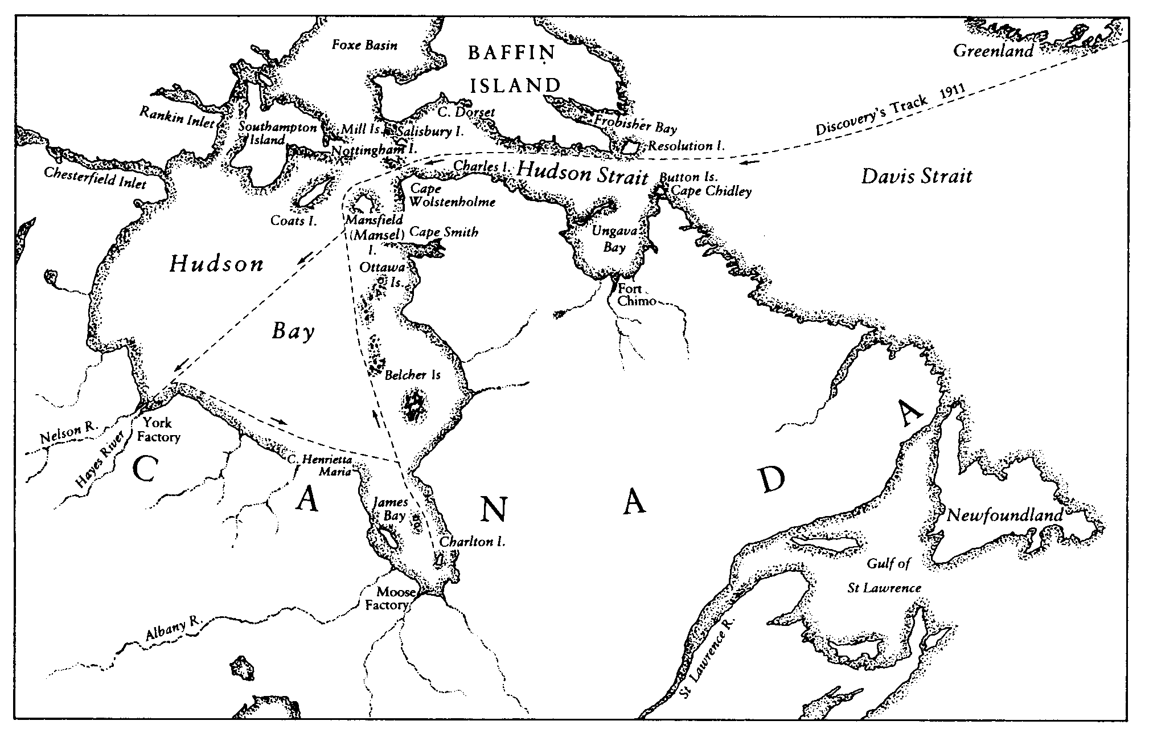
So as to provide an overview of the areas where the whalers operated and Franklin’s Expedition perished the above shows the track of the RRS “Discovery” on her voyage from the UK to Hudson Bay during the 1911 season whilst under the ownership of the Hudson Bay Company. King William Island is approximately ten degrees latitude north of the western shores of Hudson Bay.

What then is the connection between the Fraternity, this area of the Arctic and the Dundee whalers? Well, Captain Kilgour of the Polynia; Captain Adam of the Arctic; Captain Walker of the Erik; Captain Yule of the Esquimaux; Captain Deuchars of the Victor; Captain McLellan of the Narwhal; Captain Gravill of the Camperdpwn and Captain Mannerman of the Ravenscraig, were all likely to have been members of the Fraternity, They all took their ships to the Arctic that at one time teemed with whales, seals, narwhals and the like, at least once during the fishing season, sometimes twice. It was a harsh existence where men’s lives were at risk. It was also a lucrative profession where a great deal of money could be made in a short time, not so much by the Captains and crews but by the owners of and investors in the ships. Each of these Captains at one time or another would have provided the Admiralty with fresh information about the areas they visited, allowing navigation charts to be updated and so increase the accuracy of what was set down eventually leading to safer navigation.

Those of you who are interested in Dundee’s whaling past should visit the Friends of Dundee City Archives website at www.fdca.org.uk/Whaling_Industry.html where ‘The Dundee Whaling Industry 1756 – 1920’ story is wonderfully told with accuracy and brevity.

My geography is reasonably good but when I read about a Mr Walter Payne of 27 Gellatly Street’s donation of a piece of ‘conglomerate or pudding stone’ from the ‘Gulf of Obi Nova Zembla’, I was stumped! Where the heck was the Gulf of Obi Nova Zembla? Because I had been so intent in looking at the areas to the west of Iceland, I lost sight of the fact that Dundee whalers operated in high latitudes to the east of Iceland as well and Nova Zembla is a crescent shape group of islands well to the east of the North Cape of Norway.

Enough for now! More and attention spans diminish, at least mine does these days so I’ll use that as my yardstick in future issues.

A Good New Year to All.

John J Watson
January 2015

