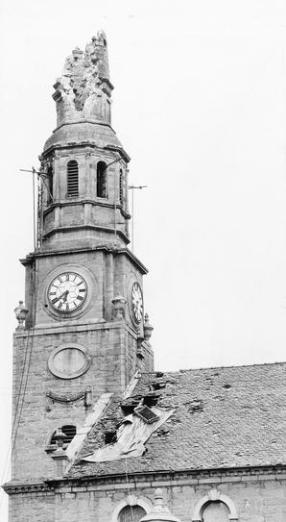
The damaged spire and roof of St Andrew’s Parish Church.
A RELATIVE mentioned a thunderstorm, which hit Dundee in the early 70s in which a church was hit by lightning. Can the Tele give info? — Reader, Dundee.
[The spire of St Andrew’s Parish Church at the foot of Dundee’s King Street was struck by lightning during a freak storm on September 8, 1970. Pieces of masonry fell through the roof of the building.
Part of the spire had to be dismantled for safety. The renovation also included major repairs to the roof of the building.
The church was closed to the congregation for more than three months.
It opened its doors in time for Christmas. At the festive service, the Rev T. R. S. Campbell baptised nine babies — a backlog from the enforced closure.
In the three months the church was closed, the congregation began the task of raising £3000 to cover their share of the cost of repairs to the church.

