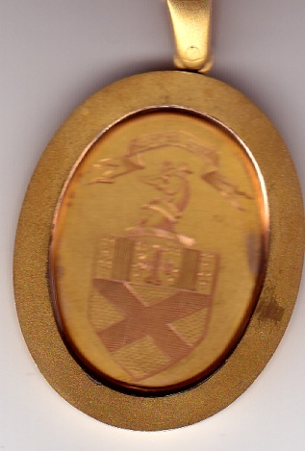
Medal presented to Clerk & Boxmaster of Nine Incorporated Trades, date unknown but believed to be pre-1890.
It was presented to

