Issue 2, November 2017
The Weaver Incorporation of Dundee Tartan was designed and woven on a handloom by Master Weaver Ashleigh Slater of Blairgowrie.

Ladies Scarf  Price - £45  Gents Scarf  Price - £55 | 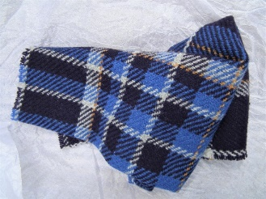 | Bow Tie  Printed Tartan  Price - £18 | 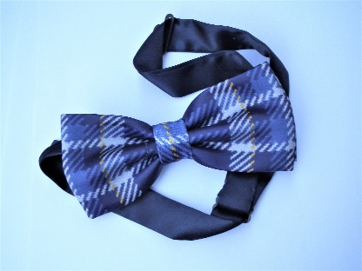
Hip Flask (Large)  8oz stainless steel  Price - £30 | 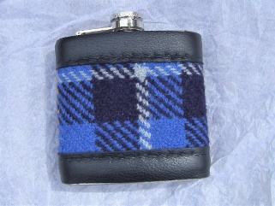 | Hip Flask  (Medium)  6oz stainless  steel  Price - £20 | 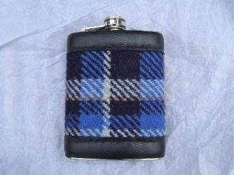
‘Scottie’  Door Stop  Price - £40 | 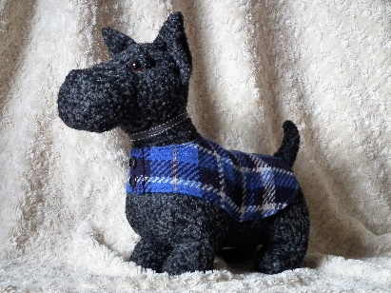 | Keyfob  Price - £10 | 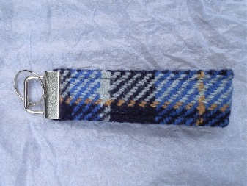
Corsage  (Rosette)  Woven Tartan  Price - £10 | 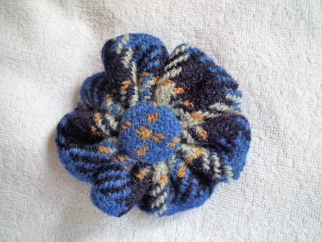 | Corsage  (Rosette)  Printed Tartan  Price - £10 | 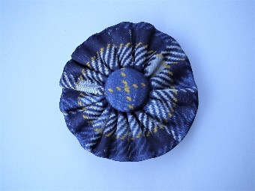
It has been decided that these items should be made available for sale to help raise monies for the Weaver Craft Charitable Funds.

Anyone wishing to purchase any of the items please contact Ashleigh Slater by email with your request at warpweftweave@live.com or Telephone Mobile No. 07846486135

Items above are made to order and payment should also be paid to Ashleigh Slater.
Address:- Warpweftweave Studio, 37 Leslie Street, Blairgowrie, PH10 6AW.

